Part A
Name:- Parva Gaglani
Roll No:- C172
Subject:- Data Structures and Algorithms
Program: B Tech/MBA Tech CE 2nd Year
Aim:
To study and implement the stack using Linked list data structure.
Prerequisite: C++ Programming
Outcome: To implement stack using linked list and its operations.
- Theory:
- Stack uses last in first out policy. Stack implemented using array is easy to implement but has a drawback. Drawback is that the array must be declared to have some fixed size. In case the stack is a very small one or its maximum size is known in advance, then the array implementation of the stack gives an efficient implementation. But if the array size cannot be determined in advance, then the other alternative, i.e., linked representation, is used.

Stack using linked list
- In a linked stack, every node has two parts—one that stores data and another that stores the address of the next node.
- The START pointer of the linked list is used as TOP.
- All insertions and deletions are done at the node pointed by TOP.
- If TOP == NULL, then it indicates that the stack is empty.

Push operation
- The push operation is used to insert an element into the stack. The new element is added at the topmost position of the stack.
Algorithm – Push
Step 1: Allocate memory for the new node and name it as NEW_NODE
Step 2: SET NEW_NODE-> DATA = VAL
Step 3: IF TOP == NULL
SET NEW_NODE-> NEXT = NULL
SET TOP = NEW_NODE
ELSE
SET NEW_NODE-> NEXT = TOP
SET TOP =NEW_NODE
[END OF IF]
Step 4: END

Pop operation
- The pop operation is used to delete the topmost element from a stack.
- However, before deleting the value, we must first check if TOP==NULL, because if this is the case, then it means that the stack is empty and no more deletions can be done.
- If an attempt is made to delete a value from a stack that is already empty, an UNDERFLOW message is printed

Algorithm- Pop
- Step 1: IF TOP == NULL
- PRINT “UNDERFLOW”
- Goto Step 5
- [END OF IF]
- Step 2: SET PTR = TOP
- Step 3: SET TOP=TOP->NEXT
- Step 4: FREE PTR
- Step 5: END

TASK 1:
Write a C/C++ program to implement the following operations of stack using singly linked list:
- Push(int val)
- Pop()
- Display()

Procedure:
- Open CodeBlock editor or visual studio editor and write the code in C++.
- Complile and run the code
Instructions:

- Copy code & paste in code section and output of Part B.

Part B
Code:
#include <iostream>
using namespace std;

// Node structure for linked list
struct Node {
int data;
Node* next;
};

// TOP pointer to track stack's top element
Node* TOP = NULL;

// Push function
void push(int val) {
Node* NEW_NODE = new Node();
NEW_NODE->data = val;
if (TOP == NULL) {
NEW_NODE->next = NULL;
TOP = NEW_NODE;
} else {
NEW_NODE->next = TOP;
TOP = NEW_NODE;
}
cout << val << " pushed onto stack.\n";
}

// Pop function
void pop() {
if (TOP == NULL) {
cout << "UNDERFLOW - Stack is empty.\n";
return;
}
Node* PTR = TOP;
cout << "Popped: " << PTR->data << "\n";
TOP = TOP->next;
delete PTR;
}

// Display function
void display() {
if (TOP == NULL) {
cout << "Stack is empty.\n";
return;
}
cout << "Stack elements (Top to Bottom): ";
Node* temp = TOP;
while (temp != NULL) {
cout << temp->data << " ";
temp = temp->next;
}
cout << "\n";
}

int main() {
int choice, val;
while (true) {
cout << "\n--- Stack Menu ---\n";
cout << "1. Push\n2. Pop\n3. Display\n4. Exit\n";
cout << "Enter your choice: ";
cin >> choice;

switch (choice) {
case 1:
cout << "Enter value to push: ";
cin >> val;
push(val);
break;
case 2:
pop();
break;
case 3:
display();
break;
case 4:
cout << "Exiting...\n";
return 0;
default:
cout << "Invalid choice, try again.\n";
}
}
}

Output:
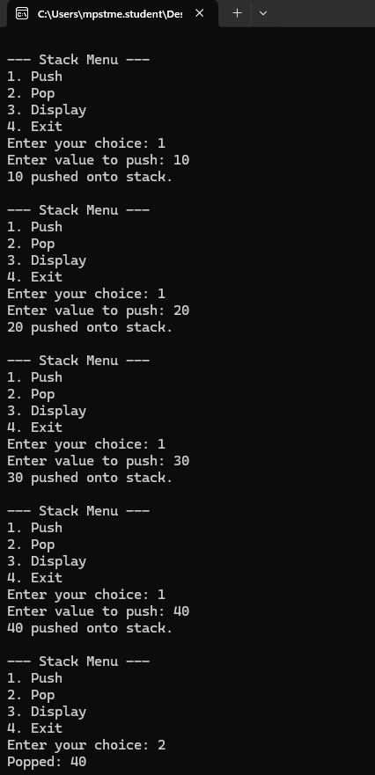

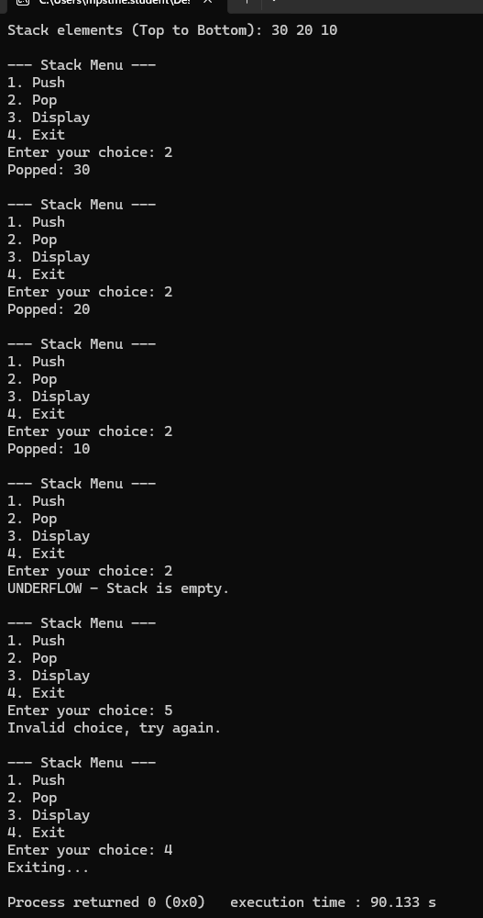
Observation & Learning:
Write your Observations & Learning after performing task
Curiosity questions:
- What is the time complexity of PUSH operation in stack using a Singly Linked list?
a) O (n)
b) O (n²)
c) O (nlogn)
d) O (1)
- d) O (1)

- 1. What is the time complexity of POP operation in stack using a Singly Linked list?
a) O (n)
b) O (n²)
c) O (nlogn)
d) O (1)
- d) O (1)

Conclusion:
We successfully implemented stack its operations usng linked list and using C++ program.

